**FRANKENSTEIN BLINKY-BOT INSTRUCTABLE**

**Level Two Build**

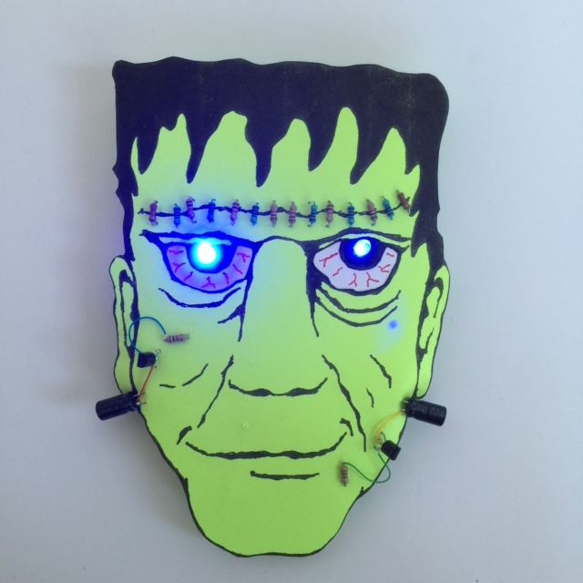

**WESTERN CANADIAN**

**ROBOTICS SOCIETY**

**INTRODUCTION**

The Frankenstein Blinky-bot described in this instructable is a Level Two project. **Completing a Level One Blinky-bot is a pre-requisite before attempting this project.** You can expect to spend a minimum of two hours building this project.

The electronic circuit for Level One Blinky-bots is quite simple, consisting of wires, a battery and some fast-blinking multi-colored LEDs. The LEDs blink because of an internal circuit in the LEDs. For the Frankenstein Blinky-bot described here (and for the comparable Witch Blinky-bot), the circuit is more complicated, with three additional components -- resistors, capacitors and transistors. Two single-colored LEDs blink in an alternating pattern, using a circuit known as an astable multivibrator. The Frankenstein Blinky-bot uses two PNP transistors, while the Witch Blinky-bot accomplishes the same task using two NPN transistors (more on this later).

The instructions presented in this booklet concentrate on assembly instructions. However, if you take the time, this project is a great opportunity to learn much more, such as:

* how to read an electric circuit schematic
* breadboarding skills
* what resistors, capacitors, diodes, and transistors do, and how they work
* how the value of the capacitors affects the blink rate
* how the same blinking pattern can be accomplished with at least three different circuits
* how to use an oscilloscope and the data it measures
* how to use a circuit simulator to design, investigate, and fine tune circuits

Obviously, a short booklet cannot cover all of these topics. However, links to other sources where you can learn about these topics are included throughout this instructable. By taking the time to go through these extra sections, you will learn valuable skills needed to design your own circuits.

**SUPPLIES**

1 – Frankenstein head printed on light green cardstock

1 – scrap piece of white cardstock (4 cm x 9 cm)

1 – 20 cm piece of black AWG30 wire

1 – 16 cm piece of red AWG30 wire

1 – 90 cm piece of yellow AWG30 wire

1 – 4 cm piece of green AWG30 wire

1 – 4 cm piece of blue AWG30 wire

1 – coin cell battery holder

1 – 3V coin cell battery (CR 2032)

1 – paper clip

2 – brads (~ 1 cm legs)

1 – 2 cm x 6 cm corrugated cardboard or plastic piece, with 2 holes punched 2 cm apart

1 – bar pin

2 – pieces of Scotch tape (2 cm long)

2 – 5 mm blue LEDs

2 - 100µF capacitors

2 – BC327B (or 2N3906) transistors or equivalent*

6 – 1 kΩ resistors**

6 – 4.7 kΩ resistors**

2 – 22 kΩ resistors**

2 – 100Ω resistors

* Note that the pinout for different types of transistors is not always the same. See the schematic in the breadboarding section.

**  Any combination of resistors can be used to create two equivalent 39KΩ resistors.

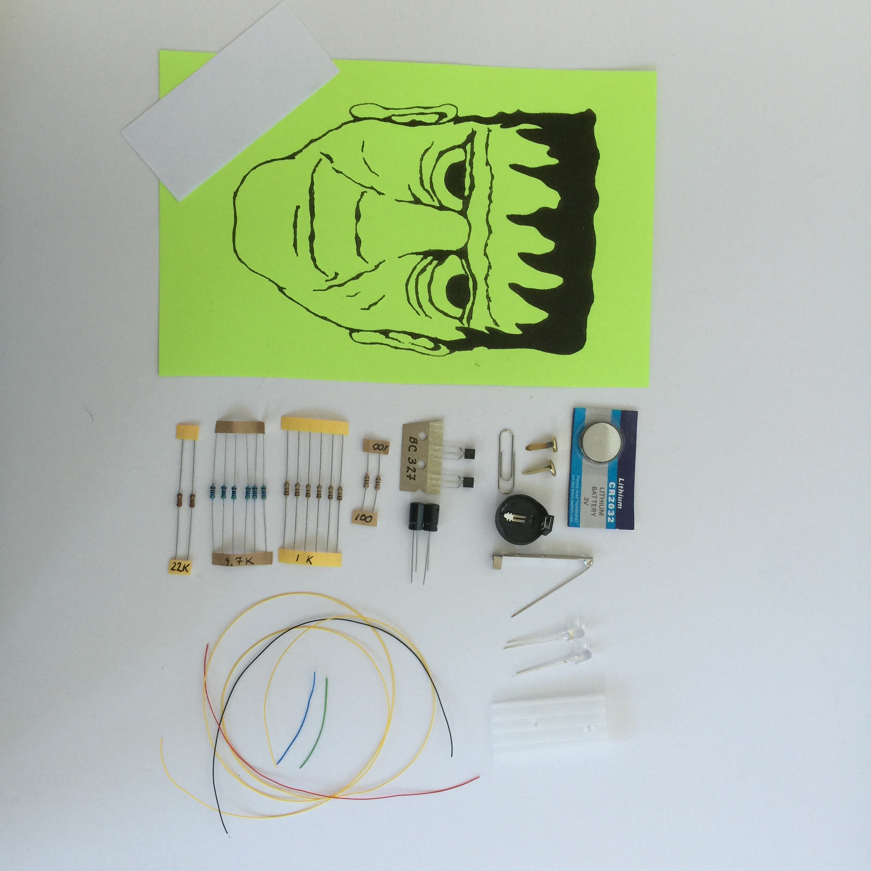

**TOOLS**

* breadboard
* 5V/3.3 breadboard power supply (optional, but recommended)
* 9V power supply (optional, but recommended)
* solid core wire of multiple colors, stripped cm on both ends (or male-male jumper wires)
* safety glasses
* hot glue gun and glue stick
* white glue
* toothpick (as a glue applicator)
* straight pin
* scissors
* wire cutters
* needle nose pliers (optional, but helpful)
* wirewrap tool with stripper
* soldering iron and solder
* ruler
* red pen or fine marker
* X-acto knife
* cutting board
* multimeter (important for troubleshooting)

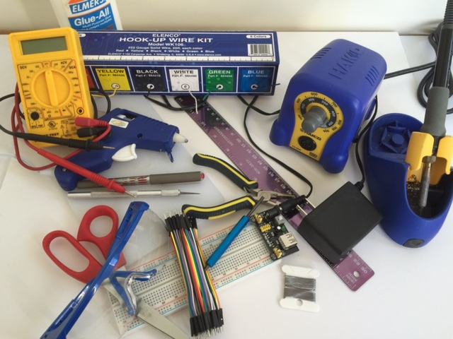

**THE CIRCUIT**

The circuit used for the Frankenstein blinky-bot is known as an astable multivibrator circuit. Two examples for an astable multivibrator circuit are shown below. The schematic on the left uses NPN transistors, whereas the schematic on the right uses PNP transistors. Both circuits produce the same result. The Frankenstein blinky-bot uses a circuit similar to the one on the right and the Witch blinky-bot uses a circuit similar to the one on the left. Note that there are many circuits to create an alternating blinking pattern with LEDs. (See the section on ***Getting the Most Out of This Project***. Note that the components supplied for this kit are different than the example shown below.)

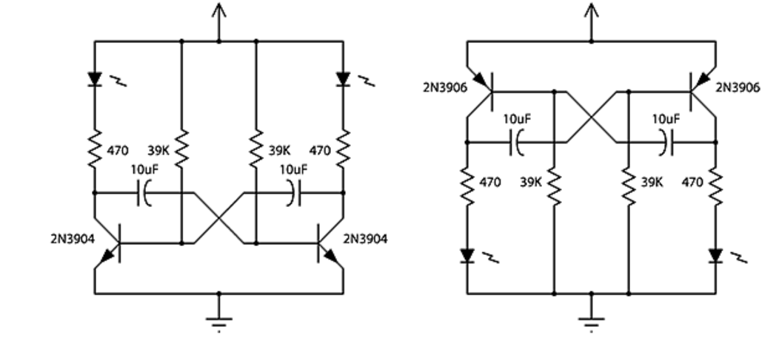

From: http: //led-circuits.blogspot.ca/2011_02_14_archive.html (See the section on 2 Transistor LED Flasher.)

**How to Read a Circuit Schematic**

Simply stated, a circuit schematic is a map, which shows how electronic components are connected between a power source and ground. To be able to build circuits, you will need to know the symbols for various electronic components. For this project, you will need to know the symbols for diodes, resistors, capacitors, transistors, and batteries. (Note that LED’s are a type of diode, as LED stands for light emitting diode.) You also need to be careful of polarity when connecting your components. If a component has polarity, the positive end must be connected toward the power source and the negative end must be connected toward the ground. If a component does not have polarity, it may be connected in either direction. There are many sources to learn about circuit schematics. Here is one such source:

<https://learn.sparkfun.com/tutorials/how-to-read-a-schematic>

**Resistors**

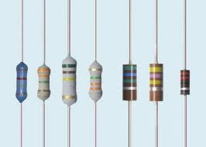

A resistor restricts the flow of current, in much the same way that a water faucet restricts the flow of water. Resistors help channel current flow in the right direction and protect other components, such as LEDs, from receiving too much current. Resistance, voltage, and current are related according to Ohm’s Law. Learn about resistors and Ohm’s Law here:

<https://www.youtube.com/watch?v=Gc1wVdbVI0E>

Resistance is measured in ohms. If you have not already done so, now is a good time to learn about how to use a multimeter to measure resistance.

<https://www.youtube.com/watch?v=TdUK6RPdIrA>



**Capacitors**

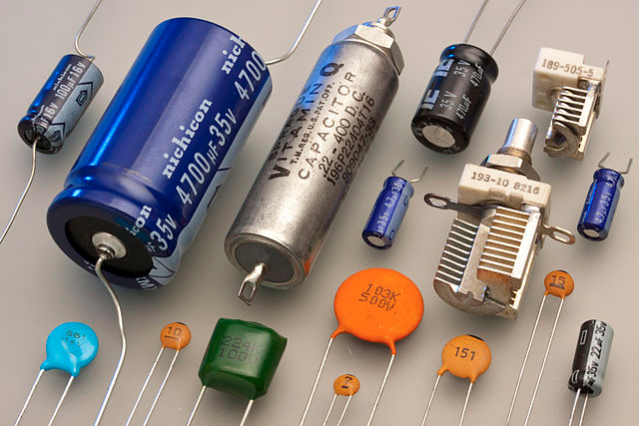

Capacitors store and discharge energy, much like a battery. The difference is that batteries store their energy in a chemical form, whereas capacitors store their energy in an electric field. Capacitance is measured in Farads. Larger capacitors have polarity, whereas smaller capacitors often do not. Here is one source to learn more about capacitors:

<https://www.youtube.com/watch?v=0gZKik_BhQQ>

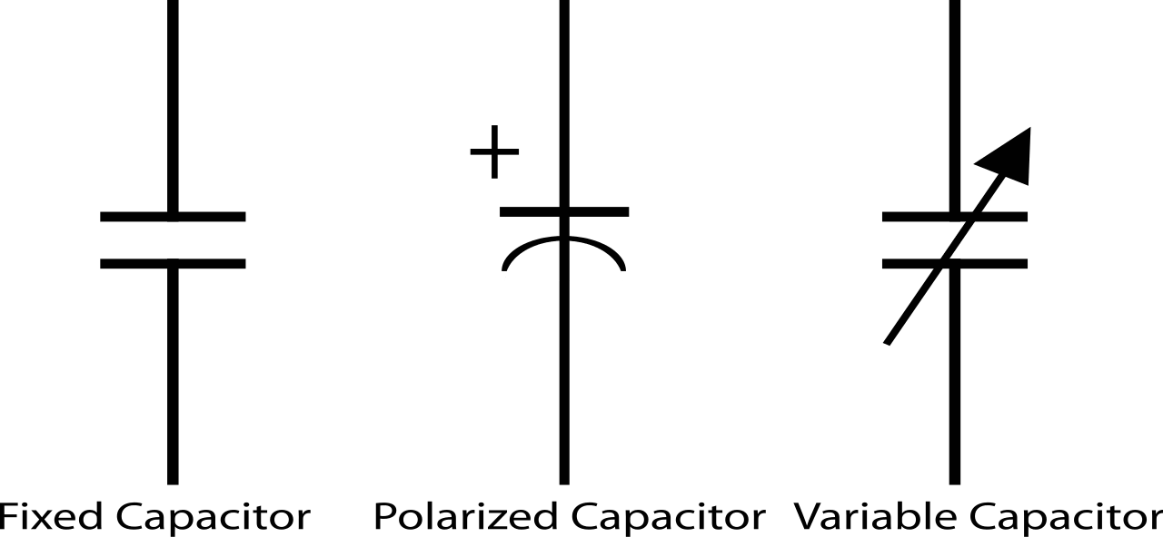

**Diodes**

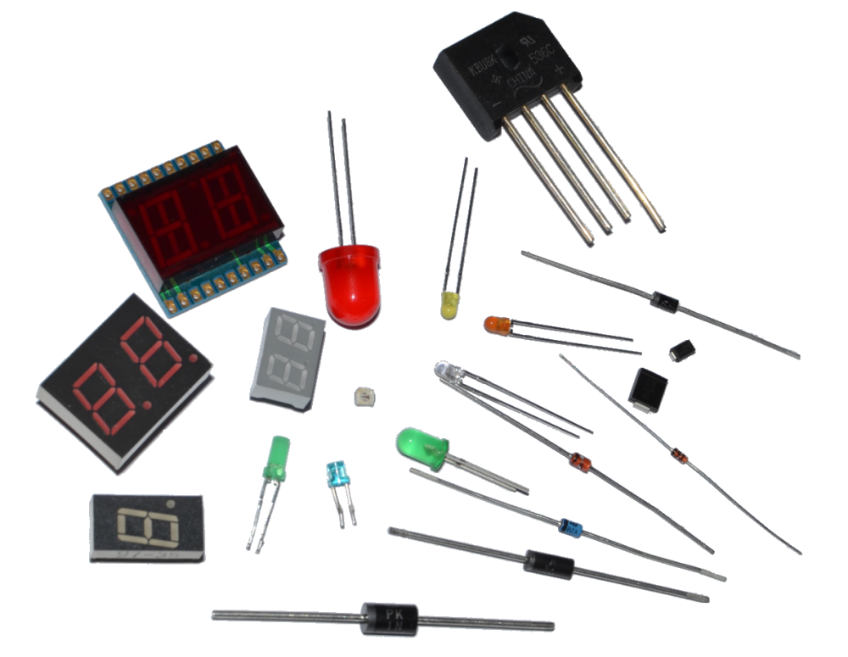

A diode acts like a check valve; it allows current to flow in one direction and resists current flow in the other direction. Consequently, diodes have polarity. LEDs (light-emitting diodes) are just one of many types of diodes. The basis for a diode is a PN junction, which is also an important concept for transistors. To learn about PN junctions and diodes, check out:

<https://www.youtube.com/watch?v=ar7xDMR4P_U>

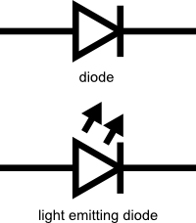

**Transistors**

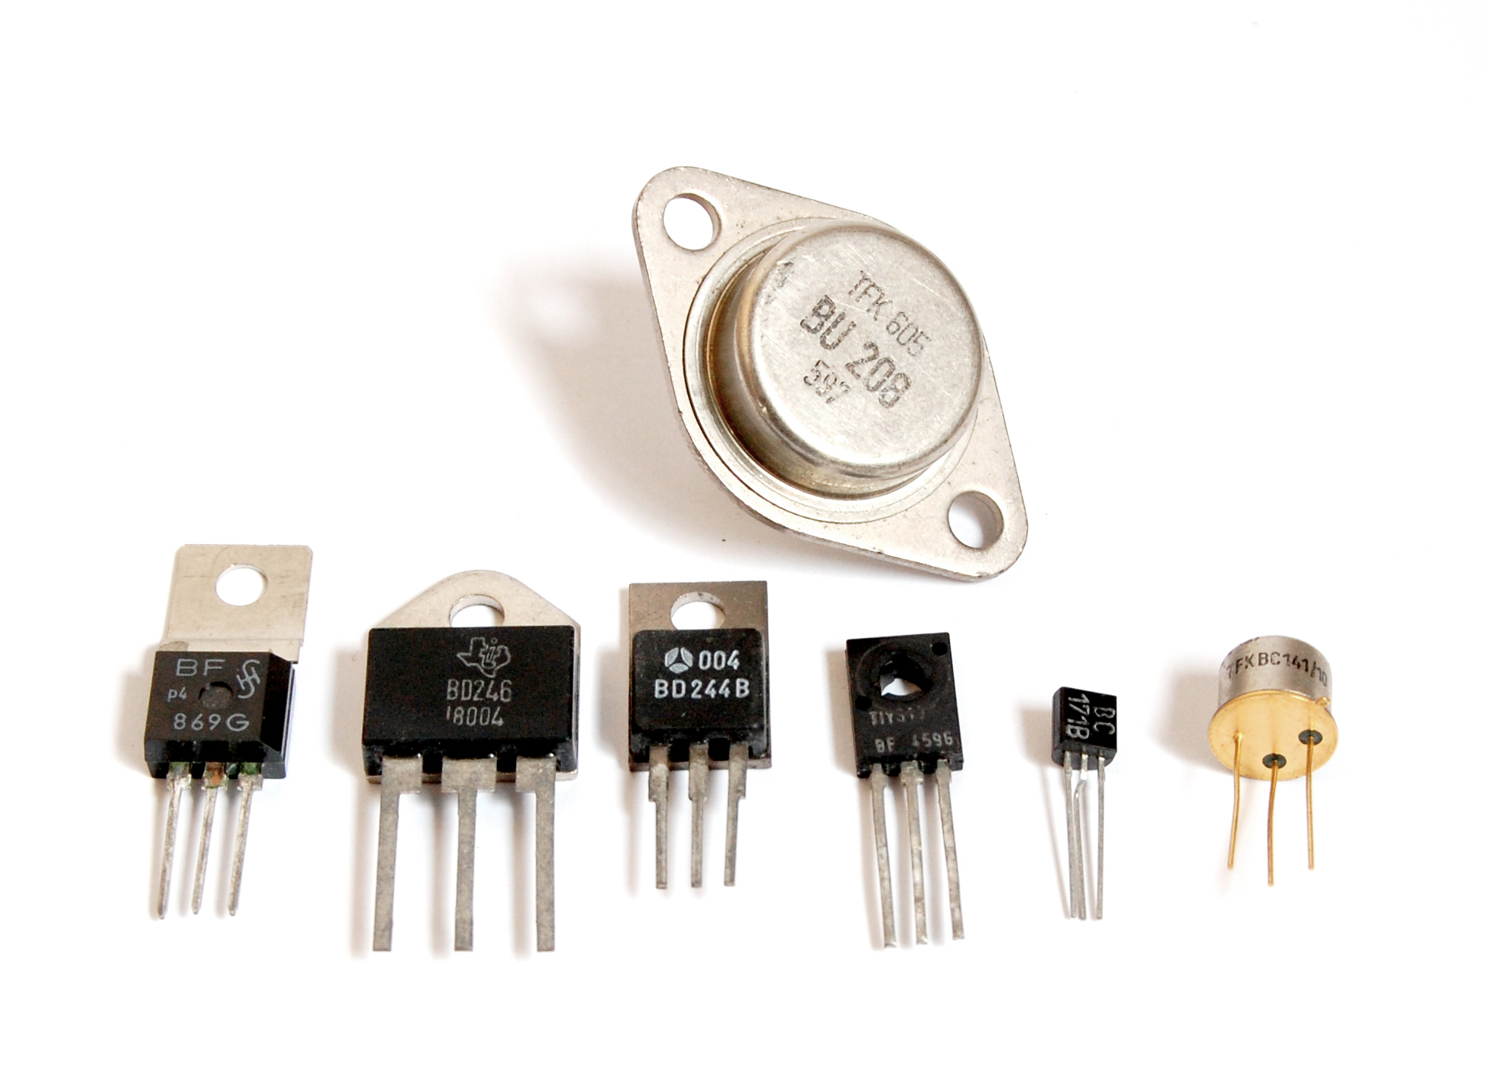

A transistor can be used as a switch or as an amplifier. In the case of the Frankenstein robot, the two transistors function as switches. (You can clearly see how the transistors function as switches if you do the simulator exercise.) When placing transistors in a circuit, make sure to carefully check the datasheet for the transistor to correctly identify the base, collector, and emitter legs. To learn more about transistors, check out the following sites:

<https://www.youtube.com/watch?v=7ukDKVHnac4>

<http://www.explainthatstuff.com/howtransistorswork.html>

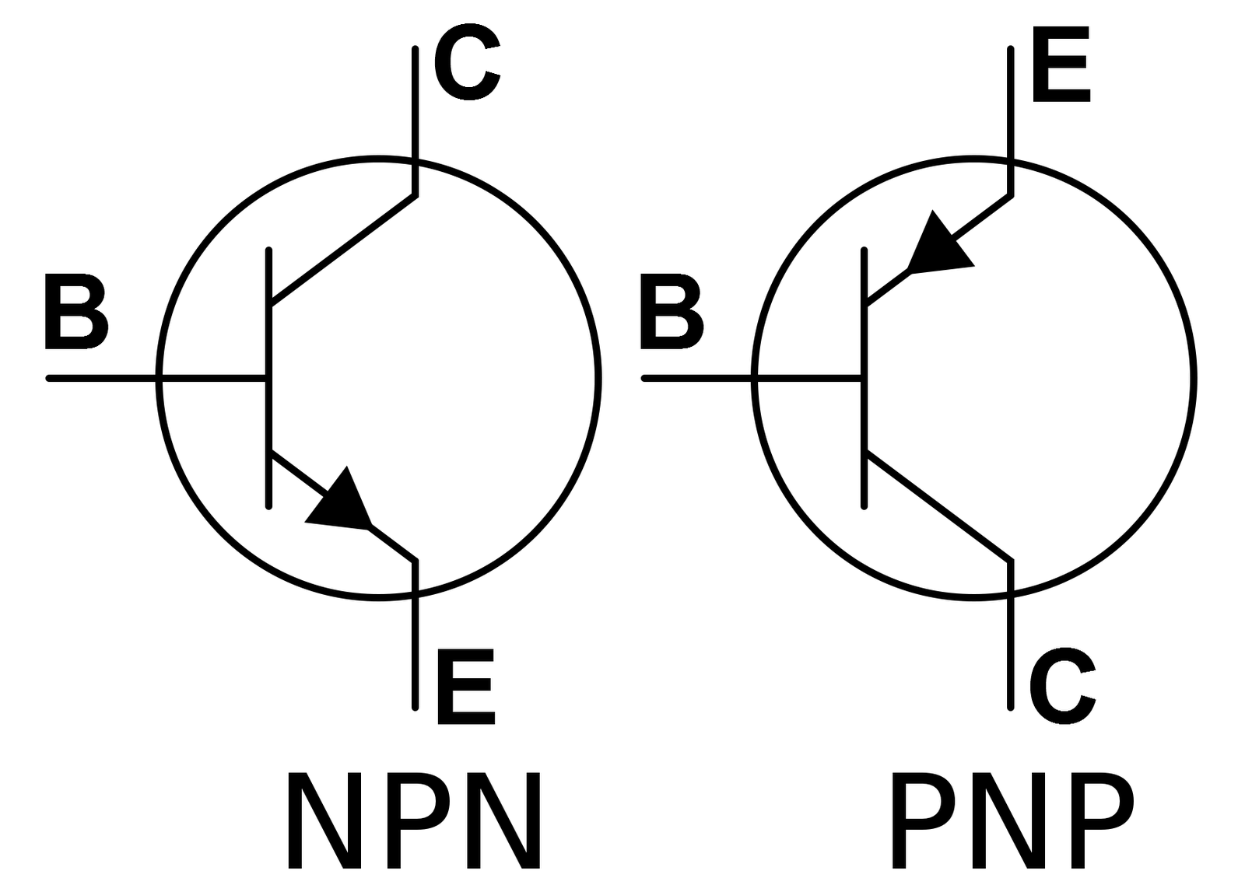

**BREADBOARD THE CIRCUIT**

The circuit for the Frankenstein Blinky-bot is sufficiently complicated that it is strongly recommended that you breadboard the circuit first. Troubleshooting a circuit on a breadboard is much easier than trying to troubleshoot a circuit that has already been soldered. Once you have the circuit working properly on the breadboard, you can then transfer it to the cardstock.

**How to use a Breadboard**

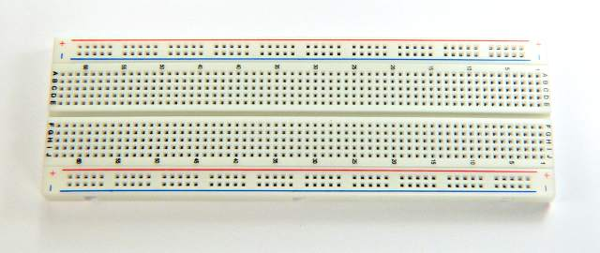

There are many Internet sources that explain breadboarding. Here is one such source:

<https://www.youtube.com/watch?v=6WReFkfrUIk>.

It is important to understand how to supply power to a breadboard and which the rails (or rows) on a breadboard are common (connected). Note that, by convention, the red rail is connected to power and the blue/black rail is connected to ground.

Following the schematic below, construct the astable multivibrator circuit on a breadboard.

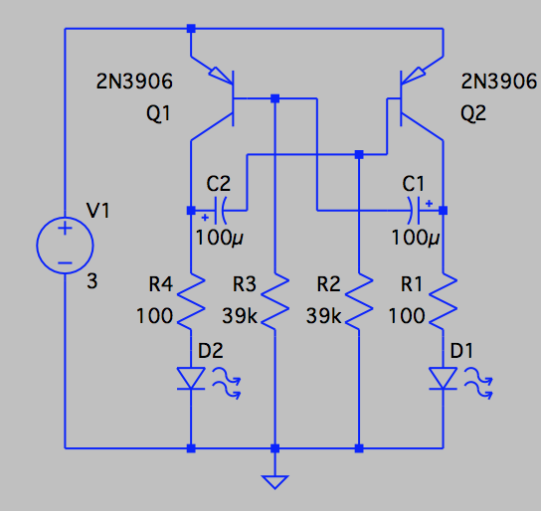

Note that any combination of resistors can be connected in series to make up the 39K resistors. (These are the resistors that will form the “stitches” across Frankenstein’s forehead.) When resistors are connected in series, the equivalent resistor value is found by adding all the resistor values. The order in which the resistors are placed in series is not important. In the Frankenstein kit, each 39KΩ resistor is made up from three 1KΩ resistors, three 4.7KΩ resistors, and one 22KΩ resistor.

Note that LEDs have polarity. The long leg of the LED is positive, so it is connected to the power side. The short leg is negative, so it is connected toward the ground side.

Note that the capacitors also have polarity. Like the LEDs, the long leg is positive, so it is connected to the power side. The short leg is negative, so it is connected toward the ground.

All PNP transistors are represented by:



However, as shown below, the pinout (arrangement of the leads) depends on the transistor number. Two transistors types may be functionally identical, but the position of the base, emitter and collector legs is often different. So it important to be aware of which transistor you are using. Datasheets (readily available on the Internet) are a good source to verify the pinout.

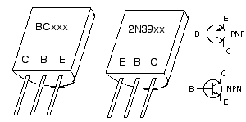

Once you have completed the circuit on a breadboard and carefully checked it for errors:

* Set the breadboard power supply to 3.3V.

* Connect the 9V power supply to the breadboard power supply. (Alternatively, you can use the 3V coin cell as a power supply. However, if you do a significant amount of troubleshooting or experimentation, a battery may not last very long.)
* The LEDs should blink in an alternating pattern. If they don’t, turn the power supply off and troubleshoot the circuit. A multimeter is useful to check connectivity.

**Getting the Most Out of This Project**

With your circuit working and before you solder it into a finished product, now is a good time to experiment with it and to customize it to your own preferences.

Some questions that you might investigate are:

* How is the blinking rate affected by the value of the capacitors? For example, try substituting a 47µF capacitor for the 100µF capacitor. What happens if you have capacitors with two different values in your circuit?
* How does supply voltage affect the blinking rate? Try changing the voltage of the power supply from 3.3V to 5V.
* How is the blink rate affected by changing the color of the LEDs?
* How is the blink rate affected by changing the resistance of the 39K resistor?

Here are some other activities to try:

* Get one of our mentors to help you hook up an oscilloscope to your circuit and measure the current flow through different parts of your circuit, especially through the LEDs and capacitors.
* Model the circuit in a circuit simulator, such as LTSpice or CircuitLab. How close does the blinking rate predicted by the model match your breadboard circuit. What factors might explain any differences?
* Build the same circuit with NPN transistors (the Witch blinky-bot). How do the two circuits compare?
* Build another version of this circuit with a 555 timer chip, such as described here:

<http://www.learningaboutelectronics.com/Articles/LED-flasher-circuit.php>.

**ASSEMBLING THE FRANKENSTEIN BLINKY-BOT**

* Cut out the head.
* Remove the white of the eyes, cutting around the pupils. (An X-acto knife and cutting board may help here.)
* Using white glue, glue the white piece of paper onto the back of the head, behind the eyes.
* Using a red pen or fine-tipped marker, draw in the red bloodshot marks onto the whites of the eyes.

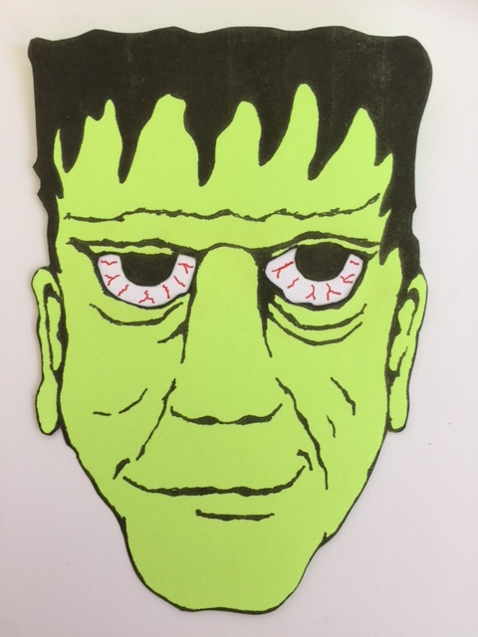

* Prepare the wire pieces. Cut the wire to length and then, using a wirewrap tool, strip the wire cm on both ends. (Normally, a wirewrap tool comes with a stripper which is designed to be used on AWG30 wire. Most other wire strippers cannot strip wire this small.)

4 – 4cm pieces of black AWG30 wire

1 – 3cm pieces of black AWG30 wire

2 – 6cm pieces of red AWG30 wire

1 – 3cm pieces of red AWG30 wire

13 – 3cm pieces of yellow AWG30 wire

5 – 9cm pieces of yellow AWG30 wire

1 – 4cm pieces of yellow AWG30 wire

1 – 3cm pieces of green AWG30 wire

1 – 3cm pieces of blue AWG30 wire

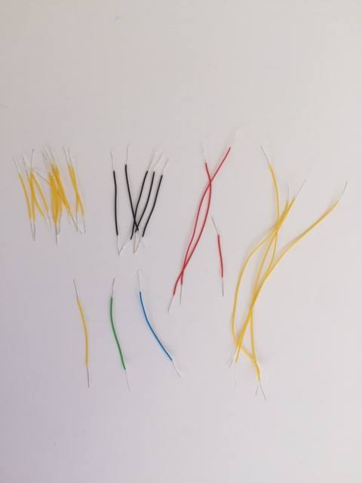

* As a general comment, when inserting components from the front of the face and wiring from the back, make sure the component leads are as far through the face as desired. Furthermore, make sure that the wire connection is close to cardstock surface before soldering in place.
* With a straight pin, punch holes on either side of the forehead scar for the 14 resistor stitches.
* Arrange the resistors, so that the resistors for one 39KΩ resistor are on one side and the resistors for the other 39KΩ resistor are on the other side. (Needle nose pliers can be helpful at this point. When bending the resistor wires, do not hold the resistor body with the needle nose pliers, as this can crush the resistor body. Instead, hold the wire leads with the pliers and bend the wire a short distance away from the resistor to avoid crushing the resistor.)

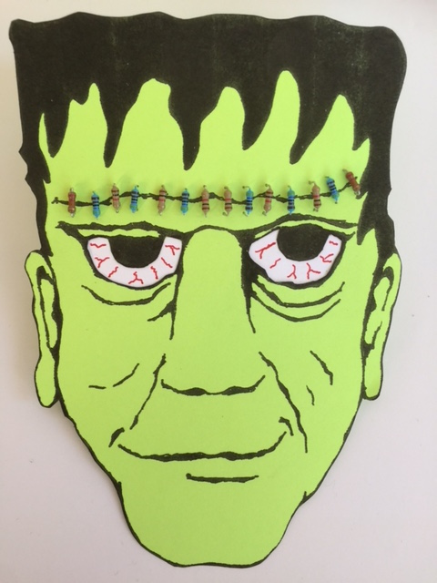

* Working from the backside, trim the resistor leads to cm.
* Starting at the lower outside corner of each side and working toward the middle, connect the resistors in series, using six pieces of the 3cm yellow wire for each. Solder the connections.
* Connect the two middle resistors with a 3cm black wire. Solder **one** of these connections.

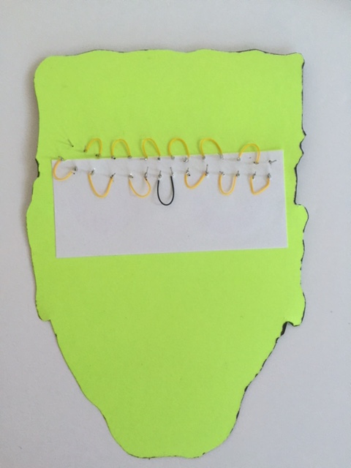

* The two wires being attached to the next three components will remain on the front of the face, but the leads will still go through the face, with additional wires connected on the backside. Therefore, keep these next two wires as close as practical to the component bodies, so that they will not interfere when the leads are fed through holes to the backside.
* Wirewrap a 3cm piece of yellow wire to the negative leg of one capacitor. Solder the connection.
* Wirewrap the other end of this yellow wire to base of a transistor. Solder the connection.
* Wirewrap a 3cm piece of green wire to the collector of the transistor. Solder the connection.
* Wirewrap the other end of this green wire to a 100Ω resistor. Solder the connection.

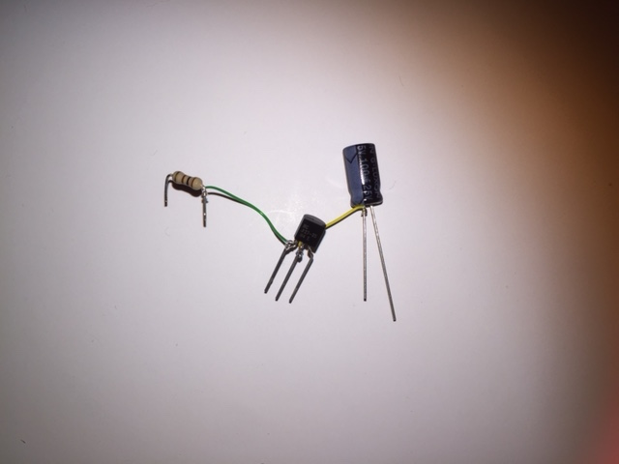

* Working on the front side and using a straight pin, punch two holes below Frankenstein’s left ear lobe and insert the capacitor. Avoid placing the holes for the capacitor too close to the edge or it may tear out. Leave about ½ cm of the capacitor leads exposed, so that capacitor will lie flat (to resemble a bolt) as shown below.

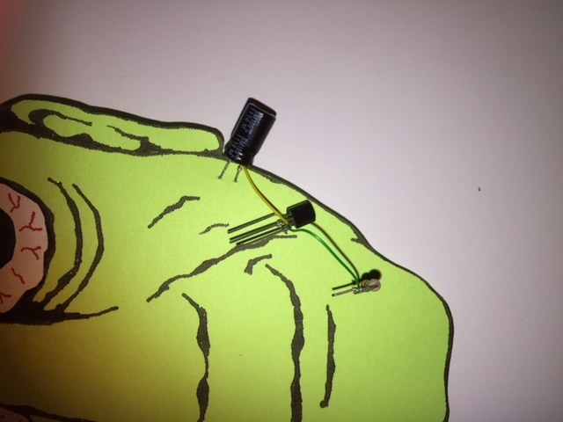

* Turn the face over to the backside. With a 9cm piece of yellow wire, connect the negative leg of the capacitor to the empty lead of the upper outside resistor of the 39KΩ series resistor. Solder in place. There should now be two wires soldered to the negative leg of the capacitor – one on the front and one on the back.

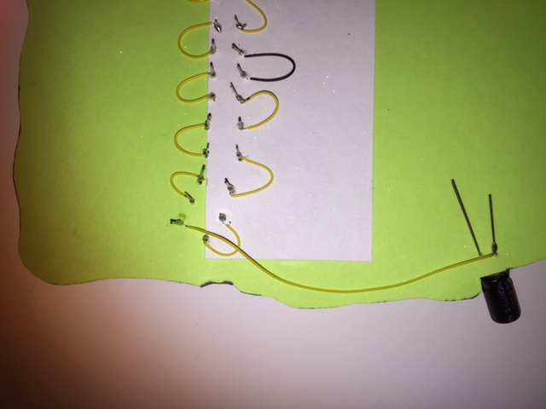

* Working from the front side and using a straight pin, punch three holes nearby on the chin for the transistor. Insert the transistor.
* Using a straight pin, punch two holes nearby on the chin for the resistor. Insert the resistor.
* Using a straight pin, punch two holes in Frankenstein’s left eye for an LED. Insert the LED.

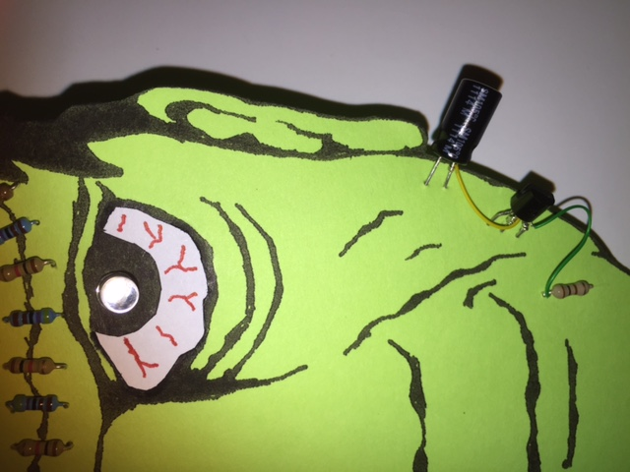

* Turn the face over to the backside. With a 9cm piece of yellow wire, connect the empty lead of the resistor (**without** the green wire) to the positive lead (long leg) of the LED. Solder in place. Trim the long leg of the LED.

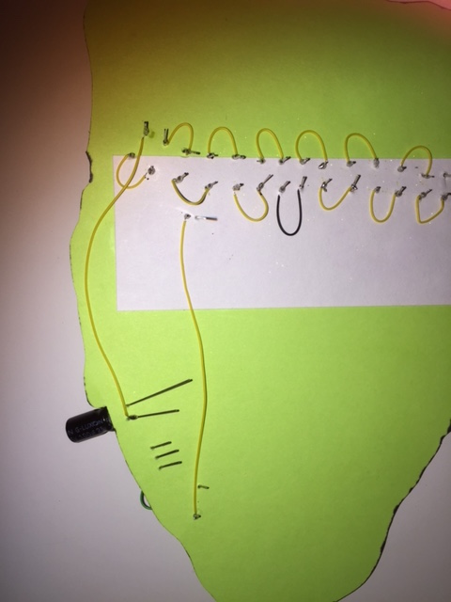

* As before, the two wires being attached to the next three components will remain on the front of the face, but the leads will still go through the face, with additional wires connected on the backside. Therefore, keep these next two wires as close as practical to the component bodies, so that they will not interfere when the leads are fed through holes to the backside.
* Wirewrap a 3 cm piece of red wire to the negative leg of the other capacitor. Solder in place.
* Wirewrap the other end of this red wire to the base of the other transistor. Solder in place.
* Wirewrap a 3cm piece of blue wire to the collector of the transistor. Solder in place.
* Wirewrap the other end of this blue wire to a 100Ω resistor. Solder in place.

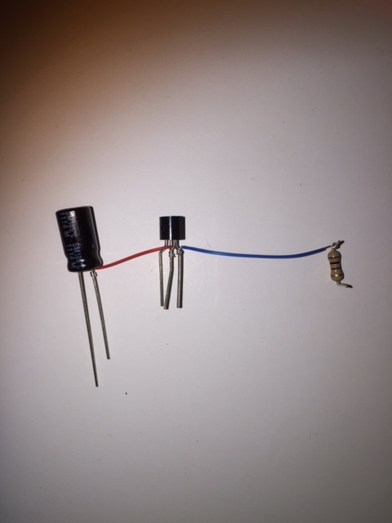

* Working on the front side and using a straight pin, punch two holes under Frankenstein’s right ear lobe and insert the capacitor.

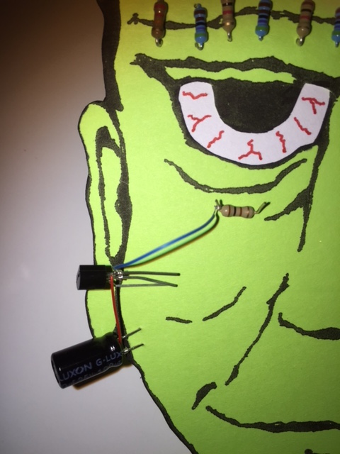

* Turn the face over to the backside. With a 9cm piece of yellow wire, connect the negative leg of the capacitor to the empty upper outside resistor of the 39KΩ series resistor (same side). Solder in place. There should now be two wires soldered to the negative leg of the capacitor – one on the front and one on the back.

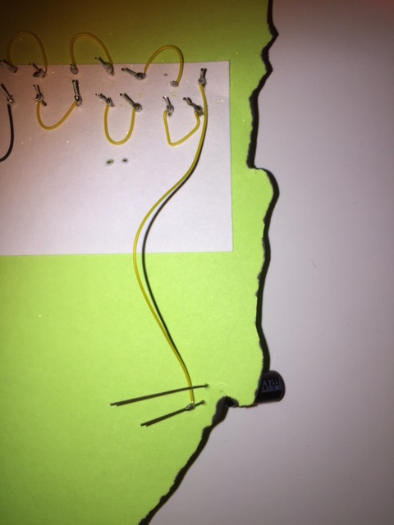

* Working from the front side and using a straight pin, punch three holes nearby on the cheek for the transistor. Insert the transistor.
* With a straight pin, punch two holes nearby on the cheek for the resistor. Insert the resistor.
* With a straight pin, punch two holes in Frankenstein’s right eye for an LED. Insert the LED.

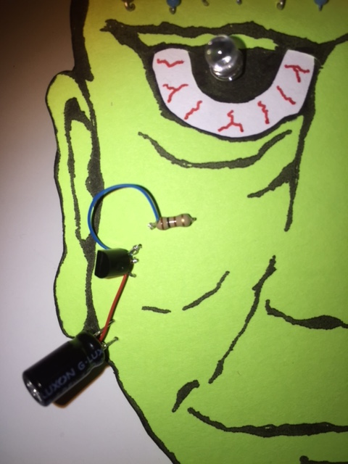

* Turn the face over to the backside. With a 4cm piece of yellow wire, connect the empty lead of the resistor (**without** the blue wire) to the positive lead (long leg) of the LED. Solder in place.
* Using a 9cm yellow wire, connect the positive side of one capacitor to the leg of the 100Ω resistor **with** the colored wire on the opposite side of the face. Repeat for the other capacitor. Solder in place.
* Tape down the legs of the capacitors with Scotch tape, so that the capacitors stand out from the face below the ears. (Hot glue may also be helpful here.)

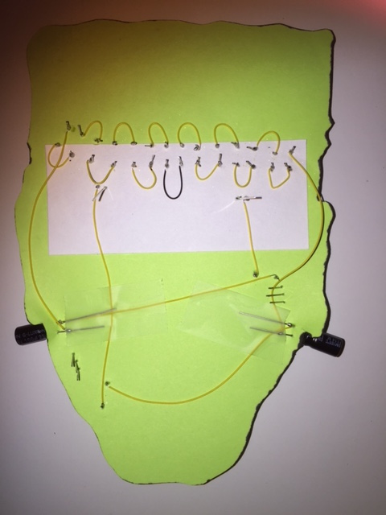

* Construct the switch as shown below, using two brass brads, a paperclip, and the corrugated plastic piece.

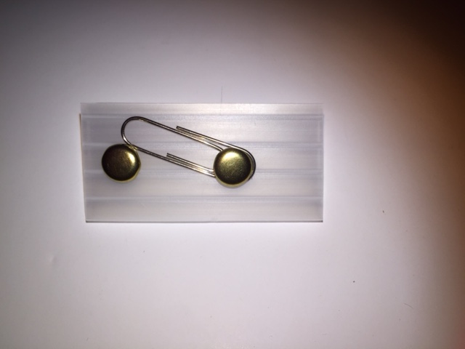

* Twist three 4cm black wires together at one end. On the backside of the plastic plece, solder the twisted end to the short end of the plastic piece. Solder one 9cm black wire to the long end. of the plastic piece.

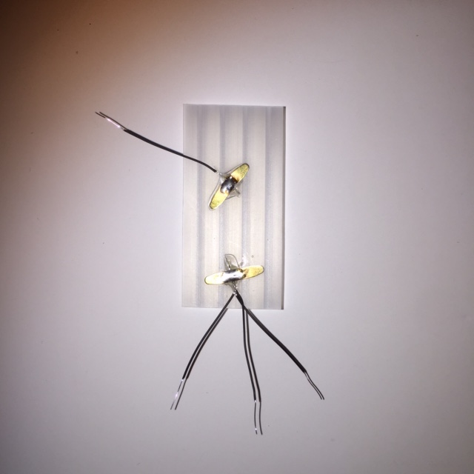

* Wirewrap and solder the single black wire to the negative end (round end) of the battery holder. Solder two 9cm red wires to the positive end (square end) of the battery holder.

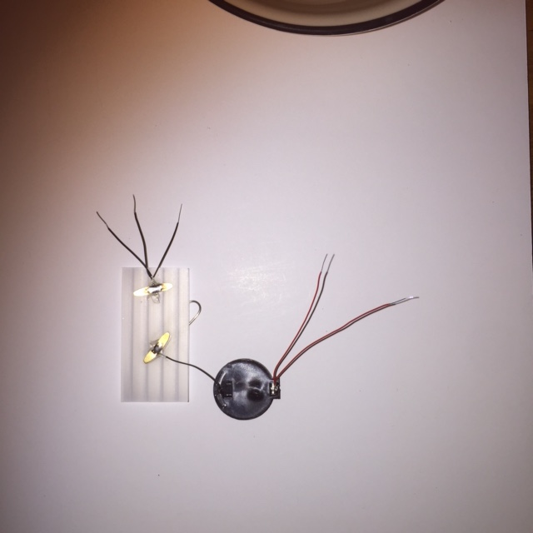

* Connect two of the three black wires to each the negative leads of the LEDs (short legs).
* Connect the remaining wire to the unsoldered leg of the resistor with the 3cm black wire. Solder all black wires in place.
* Connect the two red wires to each of the emitter legs of the transistor. Solder in place.

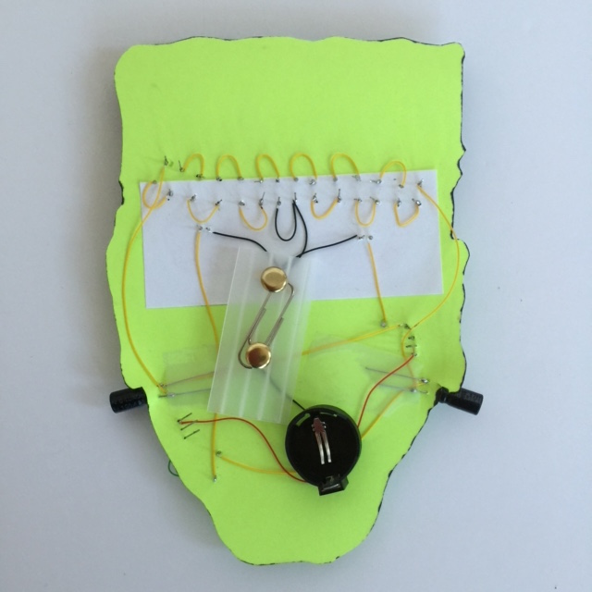

* Install a battery, close the switch, and test to make sure that the circuit works.
* Once the circuit is verified to be working, hot glue the battery holder onto the long end of the switch.
* Hot glue the switch onto the backside of the face.
* Hot glue the bar pin in place on the backside of the face, near the top of the forehead.
* Trim any protruding leads. At this point, the leads can be trimmed shorter than cm.

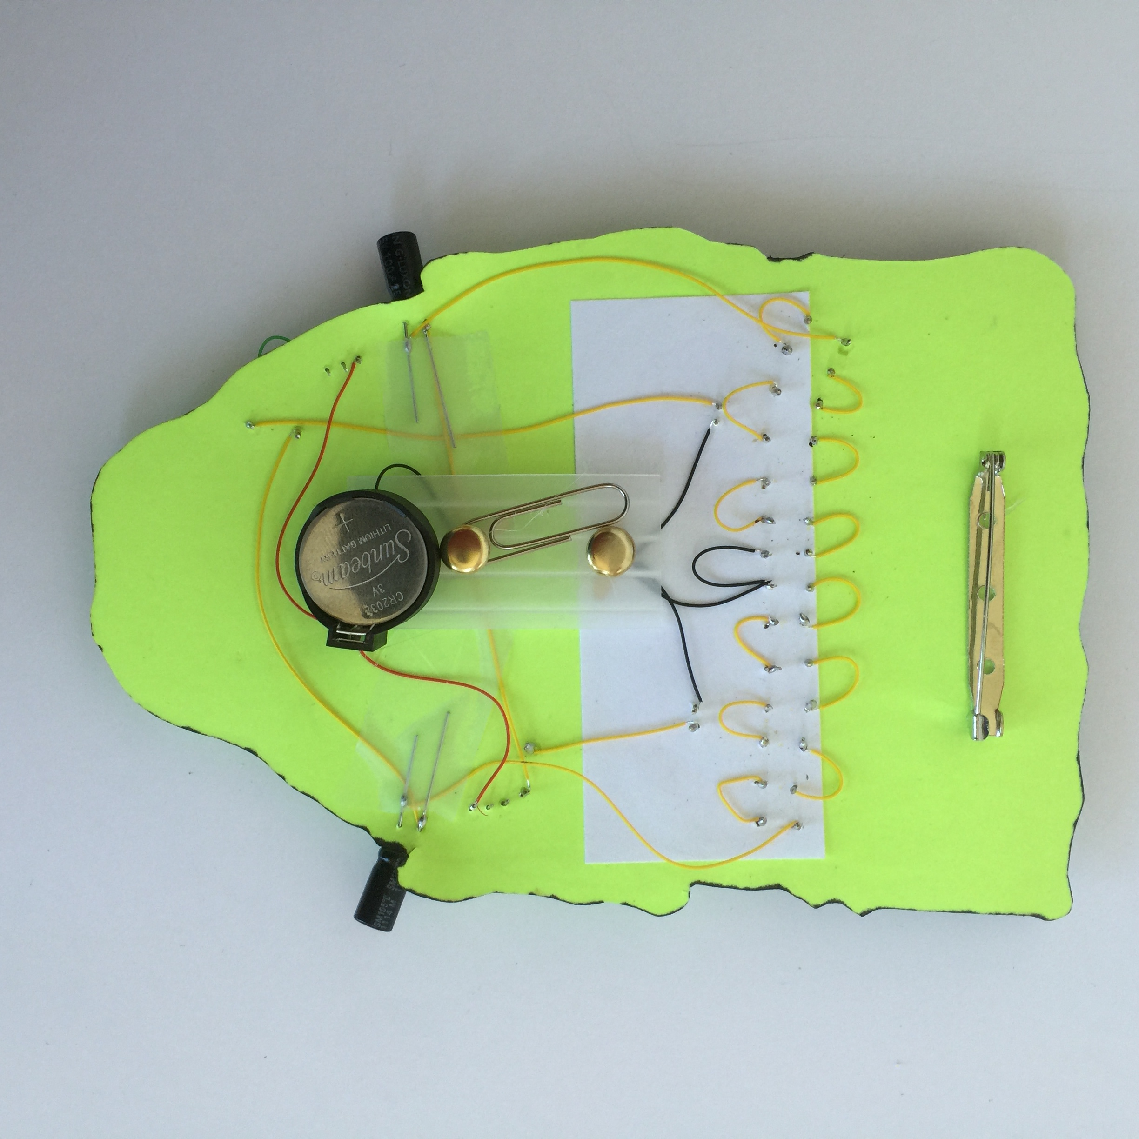



VOILA! You’re done!

